- In the signup page there’s an empty space validation is failed. Add the empty space in the first name and last name user can able to save. Fixed

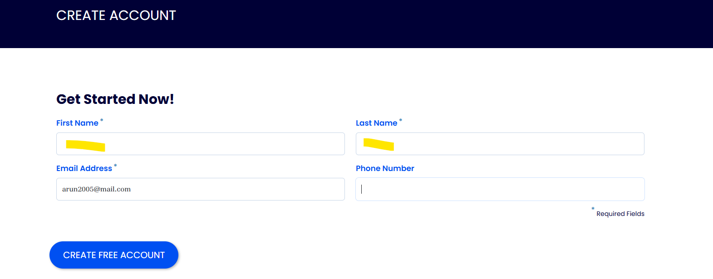

- There’s Alignment issue in the below popup, (Proceed and Stay Here are Overlapping)

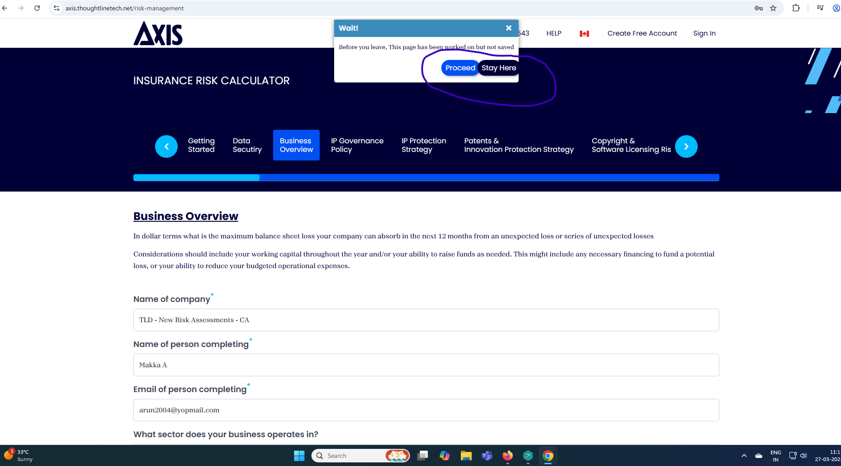

- If we login in the Axis Insurance home page we identify the some empty space in the left side , if we change that then user perspective UI can seen good.

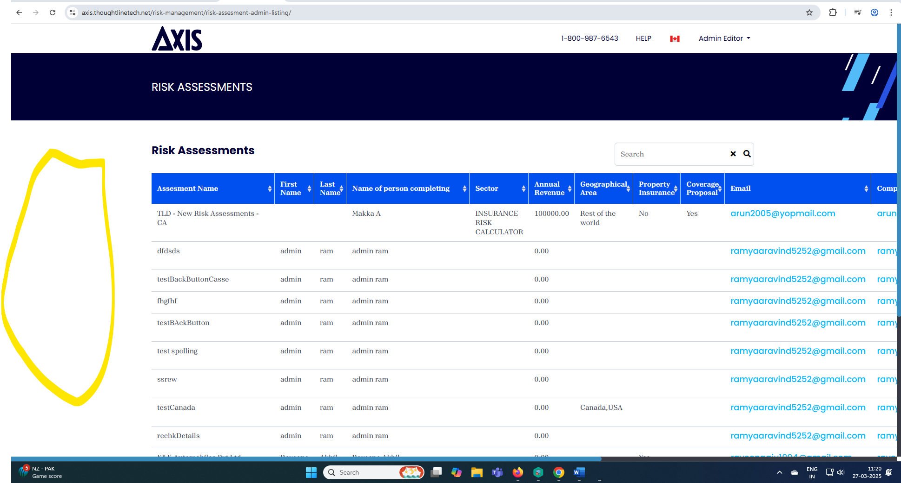

- There is alignment issue, If we login as super admin, we identify the below design issue. While we scroll right side we identify the design issue

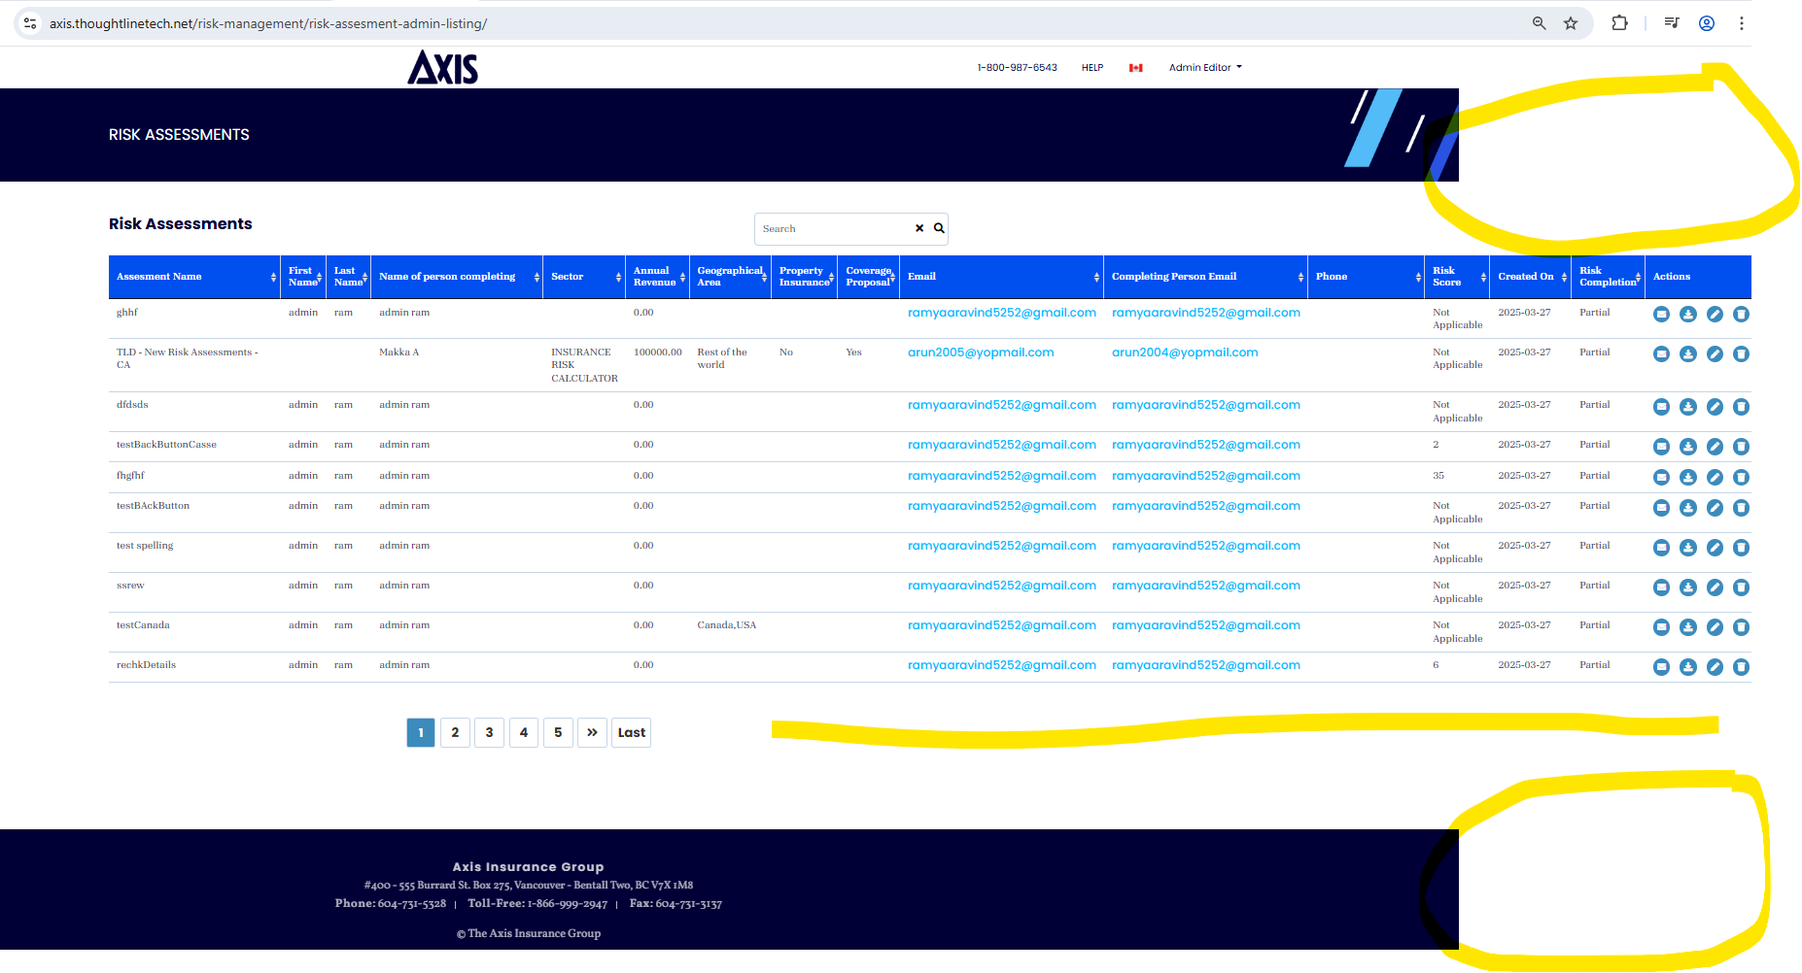

- In the super admin (Editor Page) Instead of Phone number it’s load editor email
